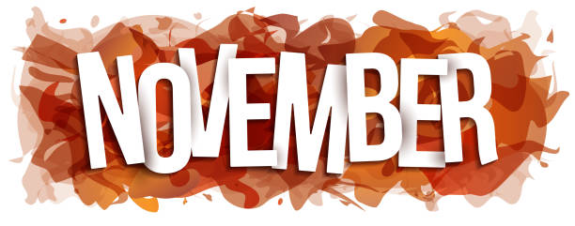
Nashua Public Library
November 2024
Library hours:
Monday, Tuesday, Wednesday 10:00 a.m. – 6:00 p.m.
Thursday 10:00 a.m. – 5:00 p.m.
Saturday 10:00 a.m. - 1:00 p.m.
Phone: 641-435-4635
You can reserve books online as well thru our online catalog, call the library if you need help:
https://nashua.biblionix.com/catalog/

Upcoming Events:
Nov., Dec., Jan. & Feb. – Feel the warmth Winter Coat Giveaway (Available while they last).
November 11, 2024 – CLOSED in observance of Veterans Day
November 13, 2024 – Library Board Meeting @ 7:00 p.m.
November 23, 2024 – Polar Express Program – 10:30 a.m. to Noon
November 25, 2024 thru November 27, 2024– Thanksgiving Make & Take Bags (Available while they last).
November 28, 2024 – CLOSED in observance of Thanksgiving
November 30, 2024 – CLOSED in observance of Thanksgiving
December 2, 2024 thru December 30, 2024 – Holiday giveaway! Stop into the library to sign up for a chance to win a basketful of goodies.
December 2, 2024 thru March 15, 2024 – Winter Book Sale – Fill a bag for $1.00! Special pricing for cake pans, DVD’s, BLU-RAY’s and Encyclopedias.
December 4, 2024 – Christmas Movies @ the library all day long.
December 11, 2024 – Christmas Movies @ the library all day long.
December 11, 2024 – Library Board Meeting @ 7:00 p.m.
December 11, 2024 – Teen Bracelet Workshop 5:00-6:00 p.m. (Open to all teens 13 and older).

December 18, 2024 – Christmas Movies @ the library all day long.
December 19, 2024 thru December 21, 2024– Christmas Make & Take Bags (Available while they last).
December 21, 2024 – Santa’s Cookies Children’s Workshop- Come make a plate and mug for Santa! (Available while they last).
December 24, 2024 & December 25, 2024– CLOSED in observance of Christmas
December 28, 2024 thru December 30, 2024– Christmas Make & Take Bags (Available while they last).
December 31, 2024 & January 1, 2025– CLOSED in observance of New Years
~~~~~~~~~~~~~~~~~~~~~~~~~~~~~~~~~~~~~~~~~~~~~~~~~~~~~~~~~~~~~~~~~~~~~~~~~~~~~~ Some of the new books we have at the library:
The Christmas Inn By: Pamela Kelley
The deaf girl By: Abigail Heringer
The boyfriend By: Freida McFadden
Social Security 101
A Christmas Duet By: Debbie Macomber
War By: Bob Woodward
Framed By: John Grisham
What I ate in one year By: Stanley Tucci
Sonny Boy By: Al Pacino
Triangle By: Danielle Steel
From here to the great unknown By: Lisa Presley
Melania By: Melania Trump
Counting Miracles By: Nicholas Sparks (LARGE PRINT)
~~~~~~~~~~~~~~~~~~~~~~~~~~~~~~~~~~~~~~~~~~~~~~~~~~~~~~~~~~~~~~~~~~~~~~~~~~~~~
