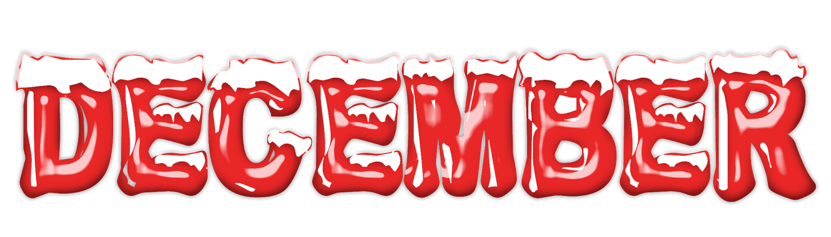
Nashua Public Library
December 2024
Library hours:
Monday, Tuesday, Wednesday 10:00 a.m. – 6:00 p.m.
Thursday 10:00 a.m. – 5:00 p.m.
Saturday 10:00 a.m. - 1:00 p.m.
Phone: 641-435-4635
You can reserve books online as well thru our online catalog, call the library if you need help:
https://nashua.biblionix.com/catalog/

Upcoming Events:
Nov., Dec., Jan. & Feb. – Feel the warmth Winter Coat Giveaway (Available while they last).
December 2, 2024 thru December 30, 2024 – Holiday giveaway! Stop into the library to sign up for a chance to win a basketful of goodies.
December 2, 2024 thru March 15, 2024 – Winter Book Sale – Fill a bag for $1.00! Special pricing for cake pans, DVD’s, BLU-RAY’s and Encyclopedias.
December 4, 2024 – Christmas Movies @ the library all day long.
December 7, 2024 – Santa Saturday! Santa and Mrs. Clause here from 10 a.m. – 11:30 a.m.
December 11, 2024 – Christmas Movies @ the library all day long.
December 11, 2024 – Library Board Meeting @ 7:00 p.m.
December 11, 2024 – Teen Bracelet Workshop 5:00-6:00 p.m. (Open to all teens 13 and older).
December 18, 2024 – Christmas Movies @ the library all day long.
December 19, 2024 thru December 23, 2024– Christmas Make & Take Bags (Available while they last).
December 21, 2024 – Santa’s Cookies Children’s Workshop- Come make a plate and mug for Santa! (Available while they last).
December 24, 2024 & December 25, 2024– CLOSED in observance of Christmas
December 28, 2024 thru December 30, 2024– Christmas Make & Take Bags (Available while they last).
December 31, 2024 & January 1, 2025– CLOSED in observance of New Years
~~~~~~~~~~~~~~~~~~~~~~~~~~~~~~~~~~~~~~~~~~~~~~~~~~~~~~~~~~~~~~~~~~~~~~~~~~~~~~ Some of the new books we have at the library:
In too deep By: Lee Child
The wall of life By: Shirley MacLaine
Dreaming of Autumn skies By: V.C. Andrews
The December Market By: RaeAnne Thayne
Distant Sons By: Tim Johnston
From here to the great unknown By: Lisa Marie Presley
The grey wolf By: Louise Penny
On the hunt By: Iris Johansen
Unleashed By: Boris Johnson
Taste of Home Grandma’s Favorites - 2025
Time will tell By: Rita Mae Brown
The Bridgerton Cookbook
Celebrate the Season – 2024
Taste of Home Annual Recipes – 2025
Robert B. Parker – Hot Property By: Mike Lupica
Tooth and claw By: Craig Johnson
Growing up Urkel By: Jaleel White
The mirror By: Nora Roberts
Citizen By: Bill Clinton
Now or never By: Janet Evanovich
Trial by fire By: Danielle Steel
Southern Living Annual Recipes – 2024
From here to the great unknown By: Lisa Presley (LARGE PRINT)
Triangle By: Danielle Steel (LARGE PRINT)
Lies he told me By: James Patterson (LARGE PRINT)
In too deep By: Lee Child (LARGE PRINT)
American Hero By: James Patterson (LARGE PRINT)
A truth revealed By: Tracie Peterson (LARGE PRINT)
~~~~~~~~~~~~~~~~~~~~~~~~~~~~~~~~~~~~~~~~~~~~~~~~~~~~~~~~~~~~~~~~~~~~~~~~~~
New DVD’s / BLU-RAY’s:
It ends with us (DVD)
Beetlejuice (DVD)
Beetlejuice 2 (DVD)



