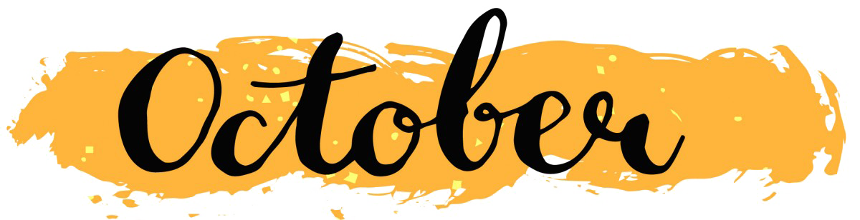
Nashua Public Library
October 2024
Library hours:
Monday, Tuesday, Wednesday 10:00 a.m. – 6:00 p.m.
Thursday 10:00 a.m. – 5:00 p.m.
Saturday 10:00 a.m. - 1:00 p.m.
Phone: 641-435-4635
You can reserve books online as well thru our online catalog, call the library if you need help:
https://nashua.biblionix.com/catalog/

Upcoming Events:

October 9, 2024 – Library Board Meeting @ 7:00 p.m.

October 10, 2024 – Flu Clinic here at the library – 1-3 p.m. with Chickasaw County Public Health.

October 16, 2024– Adult Painting Class (Scarecrow Pillow) – 5:30-6:30 p.m. **Must sign up to be included in the class. Call the library at 641-435-4635 or stop in to sign up.**

October 19, 2024 – Ninja Turtles at the library! 10:30 a.m. – 11:30 a.m. Come and meet Donny and Mikey! All ages welcome! Crafts, treats, etc. will be available while supplies last.

October 21-26, 2024 – PBS STEAM Activities will be available all week long. Stop in and see all the STEAM activities.

October 30, 2024 – Hospice Program – 5:30-6:30 p.m. with Care Initiatives as the speaker.
~~~~~~~~~~~~~~~~~~~~~~~~~~~~~~~~~~~~~~~~~~~~~~~~~~~~~~~~~~~~~~~~~~~~~~~~~~~~~~ Some of the new books we have at the library:
15 Summers Later By: RaeAnne Thayne
Capture or kill By: Vince Flynn
Safe enough By: Lee Child
Bad River By: Marc Cameron
Syndicate By: Felix Francis
Fatal Gambit By: David Lagercrantz
Den of iniquity By: J.A. Jance
Passions in death By: J.D. Robb
Confronting the Presidents By: Bill O’Reilly
Fall into temptation By: Lucy Score
The last second chance By: Lucy Score
Not part of the plan By: Lucy Score
Holding on to chaos By: Lucy Score
The fine art of faking it By: Lucy Score
Where it all began By: Lucy Score
The mistletoe kisser By: Lucy Score
Taste of Home Holiday and Celebrations
Guinness World Records 2025
Who could ever love you By: Mary Trump
Bad Liar By: Tami Hoag
Break every rule By: Brian Freeman
One big happy family By: Susan Mallery
Something lost, something gained By: Hillary Rodham Clinton
The holiday cottage By: Sarah Morgan
The Christmas Cottage By: Davis Bunn
Santa’s Secret By: Fern Michaels
Country miracles By: Nicholas Sparks
Legacy of blood By: Heather Graham
Joy By: Danielle Steel (LARGE PRINT)
Angel of vengeance By: Preston and Child (LARGE PRINT)

**We now have several books in our library by a local author from Charles City- Kylie Brant.**

~~~~~~~~~~~~~~~~~~~~~~~~~~~~~~~~~~~~~~~~~~~~~~~~~~~~~~~~~~~~~~~~~~~~~~~~~~~~~New DVD’s / BLU-RAY’s:
Fall Guy – DVD

