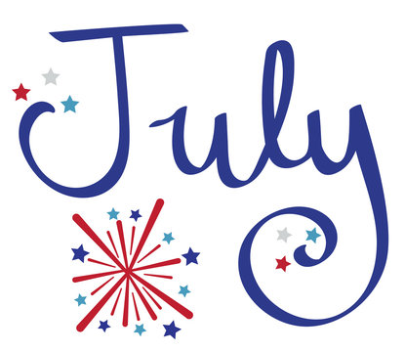
Nashua Public Library
July 2023
Library hours:
Monday, Tuesday, Wednesday 10:00 a.m. – 6:00 p.m.
Thursday 10:00 a.m. – 5:00 p.m.
Saturday 10:00 a.m. - 1:00 p.m.
Phone: 641-435-4635
You can reserve books online as well thru our online catalog, call the library if you need help:
https://nashua.biblionix.com/catalog/

Upcoming Events:
July 4, 2023- CLOSED in observance of Independence Day.
July 8, 2023- Author visit Sara Broers: 100 things to do in Iowa before you die. (10:30 a.m. – 11:30 a.m. )
July 12, 2023- Find your voice – Join us and find your own voices like Ariel the Little Mermaid. We will do crafts related to the movie the Little Mermaid. And we will have Disney Princess ARIEL here herself to take pictures and talk with you all. You don’t want to miss this MAGICAL time and a chance to meet Ariel herself at our library! This program will run from 6:00 p.m. – 7:30 p.m. to ensure everyone has a chance to meet Ariel before she has to leave. Ariel may not have time to meet you if you arrive at 7:15 p.m. so make sure to come early! We will have a professional photographer here to take pictures for us free of charge for those who chose to take a picture with the princess. We will post the pictures on Facebook for you to save and print on your own.
July 19, 2023- Find your voice thru art – Join us for Tim Read! He was here in 2019 and is coming back! He is an Author, Illustrator and Cartoonist. Remember those fun cartoons we have posted in the library on the office windows. He is the person that drew those! Come see what he will draw this year!
July 26, 2023- Find your voice thru music– Join us as we welcome the Surf Ballroom to our library for an Instrument Petting Zoo. You will have the chance to play and test out all the instruments tht they bring to our library. It may get a little noisy. We will do crafts also related to music.
August 2, 2023- Find your voice thru laughter – Join us for a fun night with Absolute Science! They will be here with their Mega Foam Blaster! This is a dry stacking foam that evaporates for easy cleanup. It shoots out 40 feet and is non-slippery, non-toxic, non-staining, non-allergenic and is also bio-degradable. It is fun for all ages, as well as the environment. Come dressed in something you don’t mind getting full of foam! Run, jump, laugh and have fun in this exciting program to end the summer program!
August 9, 2023- Library Board Meeting @ 7 p.m.
August 16, 2023- Adult Painting Workshop – Mini Barn Quilt Painting. 5:00-6:30 p.m. **Must sign up to be included in this workshop. **
August 19, 2023- National Mississippi River Museum & Aquarium - 10:30-11:30 a.m. (Dive into the amazing world of ocean creatures with the Mississippi River Traveling Touch Tank!) Pre-Registration Required: Limit of 100 participants! Sign up will be available starting August 1, 2023. You must have a ticket to guarantee a spot / and be able to do the touch tank! SIGN UP ONLY AT THE LIBRARY IN PERSON! Tickets will be given out when you sign up at the library in person! And you MUST have a ticket to get into the library during the program.
~~~~~~~~~~~~~~~~~~~~~~~~~~~~~~~~~~~~~~~~~~~~~~~~~~~~~~~~~~~~~~~~~~~~~~~~~~~~~~ Some of the new books we have at the library:
Midwest Road Trip Adventures
Tom Clancy – Flash Point By: Don Bentley
Identity By: Nora Roberts
Liar! By: Fern Michaels
Taste of Home Most Requested Recipes
Weapons of opportunity By: Dale Brown
Killing Moon By: Jo Nesbo
The survivor By: Iris Johansen
Near Miss By: Stuart Woods
Ultimate Gamers Cookbook
Never Give Up By: Tom Brokaw
Robert B. Parkers Bad Influence By: Allison Gaylin
Private Moscow By: James Patterson
5 Star Weekend by Elin Hilderbrand
Cross Down By: James Patterson
My magnolia summer By: Victoria Frank
The café at beach end By: RaeAnne Thayne
The last sinner By: Lisa Jackson
The happiness plan By: Susan Mallery
Welcome to beach town By: Susan Wiggs
Cross Down By: James Patterson **Large Print**
The Survivor By: Iris Johansen **Large Print**
~~~~~~~~~~~~~~~~~~~~~~~~~~~~~~~~~~~~~~~~~~~~~~~~~~~~~~~~~~~~~~~~~~~~~~~~~~~~
